Changhwa Hong

April 10, 2023

Analysis between 10 long-lived president and 10 shortest-lived presidents.

I found short lived presidents died before they turned 65 years old, but all Top10 lived presidents are older than 80 years old which is impressive. There is standard deviation in Top 10 lived presidents and Bottom lived presidents. The oldest U.S. president at death is Georgy H. W. Bush who died at 93 years 171 days, but the shortest-lived president is John F.Kennedy.

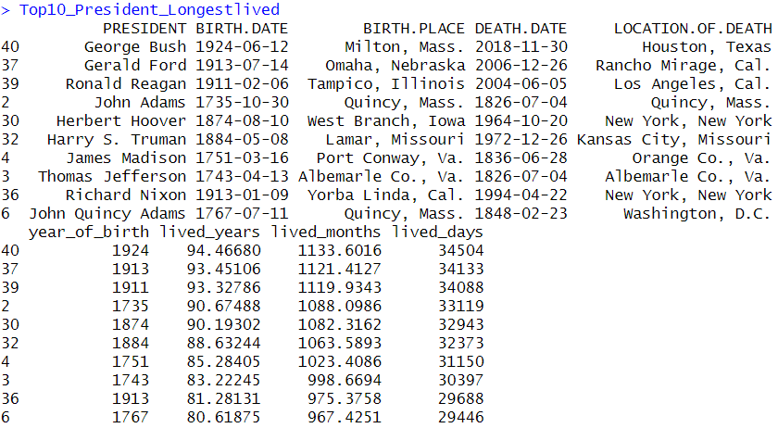

According to Box plot, Top10 Presidents longest lived have 34505 lived_days to 29446 lived day. It represents how Plot 1 50% of the points were dispersed way broader than Plot 2. However, we can find out the interquartile range is bigger in Top10 President, but very smaller in Botton10. So, it shows that Top10_Presiden. In Bottom10_President Shortest lived, lived days are between 23082 to 16978. Maximum number – minimum number is 5059 and 6104 intervals. Interesting fact, Interval is wider in Plot 2, but interquartile range is way bigger in Plot1. John F. Kenndy was assassinated at a young age. It had an impact on plot 2 interval. In Plot1 most presidents lived days are similar compared to Presidents who died at an earlier age.

In conclusion, I found President JFK assassination caused the president lived_days to lower. But the oldest top 10 presidents at death are similar.